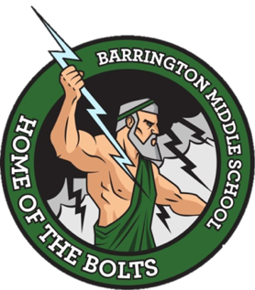

Barrington Middle School
SAC Agenda
August 24, 2022
Media Center

- Attendance

- Call to Order

- Approval of minutes from organizational meeting

- New Business
  - Welcome to the SAC PowerPoint
  - Vote on the School Improvement Plan
  - Discuss SAC bylaws

- Announcements (for the good of the group)
  - Next meeting September 28, 2022 at 8:40 AM in the Media Center

- Adjournment

